Chapter-2 | Biochemistry | Carbohydrates

- Definition, classification with examples, chemical properties
- Monosaccharides - Structure of glucose, fructose and galactose
- Disaccharides - structure of maltose, lactose and sucrose
- Polysaccharides - chemical nature of starch and glycogen
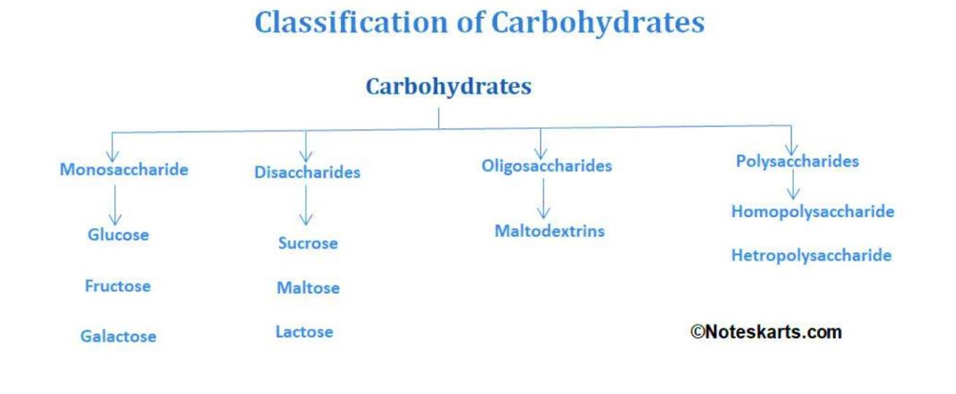
- Qualitative tests and biological role of carbohydrates
Carbohydrates:
Definition:
- Carbohydrates are polyhydroxy aldehydes or ketones or compounds derived from their hydrolysis.
- Carbohydrates are the most abundant organic constituents of plants.
- They are the major source of chemical energy for living organism (e.g. Sugars & Starch).
- It compassed of carbon, Hydrogen and Oxygen.
- The general molecular formula of carbohydrates is c(H2O). Starch and cellulose are two common carbohydrates.
Classification of Carbohydrates

Monosaccharaides:
- Carbohydrates that cannot be hydrolyzed to simpler compound are called Monosaccharide.
- Monosaccharaides have the one sugar molecule.
Classification of Monosaccharaides based on the number of Carbon Atoms:

Number of Atoms | Name | Example
3 | Triose | Dihydroxy acetone, Glyceraldehyde
4 | Tetrose | Erythrose
5 | Pentose | Ribulose, Xylulose, Ribose
6 | Hexose | Glucose, Fructose, Mannose, Galactose
7 | Heptose | Glucoheptose, Galactoheptose, Sedoheptose
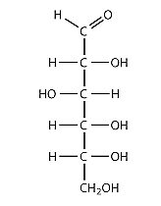
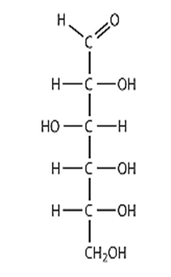

Structure of Glucose
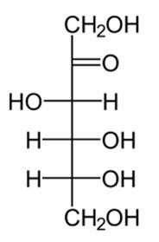
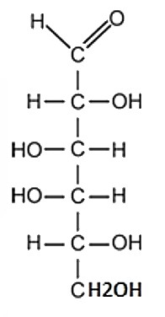
Structure of Fructose

Structure of Galactose

Disaccharides
Carbohydrates that give two monomeric units on hydrolysis are called Disaccharides.
Eg. Maltose, Sucrose, Lactose.
Classification of Disaccharides
They have two sugar molecules.
- Oligosaccharides :-

  - Carbohydrates that gives There to (10) ten monosaccharide on hydrolysis are called oligosaccharides. eg: Reffinose, Maltotriose.
  - They have two or ten sugar molecules.

- Polysaccharides:
  - Carbohydrates that give many monosaccharide on hydrolysis are called polysaccharides.
  - They have ten or more sugar molecules.
  - Polysaccharides are made-up of one or different types of sugars.

Structure of Maltose
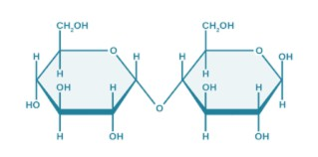
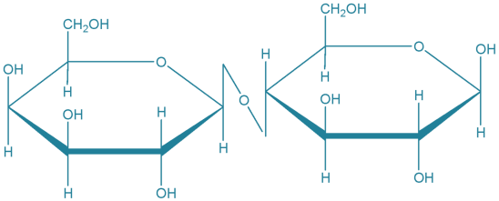
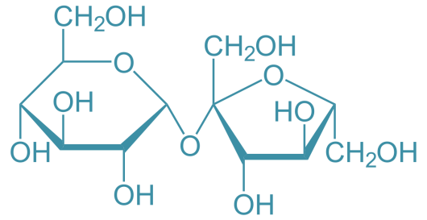

Structure of Lactose

Structure of Sucrose

Polysaccharides
  - Polysaccharides are major classes of biomolecules.

  - They are long chains of carbohydrate molecules, composed of several smaller monosaccharides.
  - These complex bio-macromolecules functions as an important source of energy in animal cell and form a structural component of a plant cell.
Classification of Polysaccharides

- Homopolysaccharides:
  - The monomeric units are arranged in the form of long chain either unbranched or branched.
  - Eg: Starch, Glycogen, Cellulose etc.

- Hetrropolysaccharides:
  - Hemicellulose is a polymer containing D-xylose, L-arabinoc, D-Galactose, LRhamnose, D- Monnose and D-Glucoronic acid
  - Eg. : Heparin
Chemical nature of Starch
- It is formed by the condensation of amylose and amylopectin. It is found largely in plants, fruits, seeds, etc.
- The chemical properties of starch are dependent on the reactivity of starch which is a function of the polyhydroxyl functional groups in the constituent glucose monomers.
- The hydroxyl groups at position C-2, C-3 and C-6 which are free from the glycosidic bond linkages and pyranose ring formation, are usually free for substitution reactions involving either the attached hydrogen or the entire hydroxyl group.
Chemical nature of Glycogen
  - It is made up of a large chain of molecules. It is found in animals and fungi.
  - It can be obtained by decomposition through the action of water.
  - It is a major fuel store in plants, but is absent from animals where the equivalent is glycogen.

Chemical reactions and Qualitative teste for Carbohydrates:-
- Dehydration:-
  - Carbohydrates on dehydration give for fural or its derivative.
  - Concentrated sulphuric acid is used as a dehydrating agent.

Molisch test :
It is general test for Carbohydrates identification
Furfural or its derivative formed during dehydration, react with α- nepenthes to giveviolet colour.
  - In this test concentrated sulphuric acid is used as a dehydrating agent.
- Reactions of carbonyl group:
- Benedict’s test –
  - Carbohydrate is wanted with alkaline copper sulphates.
  - Copper ions get reduced and give red precipitate of cuprous oxide.

Note:- All reducing Sugars give this test positive while sugar like sucrose does notgive this test positive.

- Barfoed’s test:
  - This test’s used for the identification of reducing mono-saccharidies.
  - In presence of weak acidic condition only mono-saccharidies can

reduce copper ionto give red precipitate.
- Fehling’s Test :-
  - Reducing sugar reduces the copper ions present in the Fehling solution so as to givered precipitate.
- Formation of asazone:
  - When reducing Sugar is heated with phenyldyrazine yellow crystalline compoundcalled osazones are formed.
  - e.g.
D-Glucose +Phenylhydrazine →Glucose (Yellow crystal) Phenyldyrazine + H2O
- Reduction:-

  - The carbonyl group of sugar can be reduced by variety of reagents suchas Hydrogen and platinum to an alcohol.
  - Such Carbohydrate derivatives are called alditols.
  - Important example are sorbitol glycerol rabitol.

- Oxidation:
  - Sugar are oxidation gives acid. The oxidation product depends upon oxidizingagent used in the reaction.
  - g. Glucose is oxidising to different products with the help of different oxidizingagents.

- Mucic Acid test:
  - This is used for identification of galactose and lactose.
  - Galactose or Lactose on oxidation in presence of conc.

Nitric acid givesgalactosaccharid acid (Mucic Acid).
- Iodine test:
  - Iodine reacts with starch dextrin and Glycogen to form a coloured complex.

S. No | Type of Polysaccharide | Colour with Iodine
1 | Starch | Blue
2 | Dextrin | Brown
3 | Glycogen | Pink
4 | Amylose | Deep Blue
5 | Amylopectin | Purple

Disease related to Carbohydrate metabolism:-

    - Various disorders have been reported due to abnormal metabolism ofCarbohydrates.

- Diabetes mellitus:-
    - It is a group of metabolic disorders with a common characteristics feature ofhyperglycemia.
    - Hyperglycemia in diabetes mellitus due to defect in insulin action insulin secretionor both.
    - Diabetes comes from the Greek words “Siphon” and Implies that a lot of urine ismade.
    - The second term Mellitus come from the Latin word “Mel” which means Honey.
Diabetes mellitus is broadly classified into 2 categories.
  - a) Type 1 Diabetes
  - b) Type 2 Diabetes

    - Type 1 Diabetes:-
- It is characterized by absolute deficiency of insulin due to distruction of B-cell ofpancreas.
- A chronic condition in which the pancreas produce little or no insulin.
Symptoms:-
- Increase Thrust
- Frequent Urination
- Hunger
- Fatigue

    - Type 2 Diabetes:-
- This this type of diabetes a due to inadequate secretion of insulin by B- cells ofpancreas.
- In this type of diabetes the body either does not produce enough insulin.
Symptoms:-
- Increase thirst
- Frequent Urination hanger
- Fatigue
- Blurred vision.
Note:- Normal
range- (70-120mg/dl) High range – (←200mg/dl)

- Glycosuria :-
- when Glucose is excreted in urine the condition is called as glycosuria.
- Glycosuria occurs due to elevated blood glucose level.
- Glycosuria more common during pregnancy.

- Galactosemia:-
- Due to deficiency of enzyme galactose 1-phosphate luridly transferees andGalactosemia.
- Galactose cannot be converted in glucose which leads to a condition called asGalactosemia.
- It is characterized by increased galactose level in circulation and urine.
- Accumulated galactose into galactic which responsible for development of cataract.

Symptoms:-

- Jaundice
- Hepatospicenmegaly
- Mental retardation, etc.

- Fructose intolerance:-

- One of the very normal hexose sugars of fruits (i.e. Fructose) gets normallymetabolised to give energy and CO2 but defective metabolism of fructose developed in blood, disorder know as fructose in tolerance.
- This disease occurs when calls on the surface of the intestine are not able to breakdown fructose efficiently.
- Glycogen storage disease:-
- The metabolic abnormalities related with glycogen synthesis is termed as glycogenstorage disease.
- Glycogen is main source of energy when an enzyme is missing glycogen can buildup in the liver or glycogen may not form properly.
Symptoms:-
- Not growing fast enough
- Low blood sugar
- Weak muscles.

Biochemical importance of Carbohydrates:-

  - Carbohydrates are important constituents of the cell structures in the form ofglycolipid, glycoprotein, heparin, cellulose, starch, Glycogen.
  - Carbohydrates serie as an important source and store of energy.
- Carbohydrates are important basic material for many organic compounds like-Amino acids, Nucleic acid, Lipids.
1. Carbohydrates are important row material for the industrial production of productslike – Glucose, maltose, alcohol, Acids etc.

